Emergency Continuity Power Spine
White Paper Proof of Concept for Reactor-Failure Survival Power, Waste-Heat Recovery, and Mandatory-Systems Routing
Document Type | Emergency spacecraft power continuity proof-of-concept white paper
Concept Thesis | Use CPSS as an internal emergency reserve, TPV-style layers as waste-energy reclamation, layered battery cores as thermal buffers, and prismatic routing as a mandatory-systems priority manifold after reactor failure.
Primary Use | Life support continuity, thermal reclamation, emergency load management, attitude-control support, and slow recovery operations
Status | High-level concept architecture draft
Abstract
Emergency Continuity Power Spine is a reactor-failure survival architecture built from four linked ideas: CPSS as the adaptive internal reserve, TPV-style layers as a waste-heat reclamation system, layered battery cores as thermal and transient buffers, and prismatic routing as the manifold that decides which ship functions stay alive. The point of the system is not to restore full mission capability after catastrophic power loss. The point is to salvage otherwise-wasted internal energy, preserve electrical coherence, and keep mandatory systems operating long enough for stabilization, distress signaling, and controlled recovery. In this framing, the ship does not pretend the reactor never died; it uses its remaining heat, reserve capacity, and routing intelligence to survive the death gracefully.
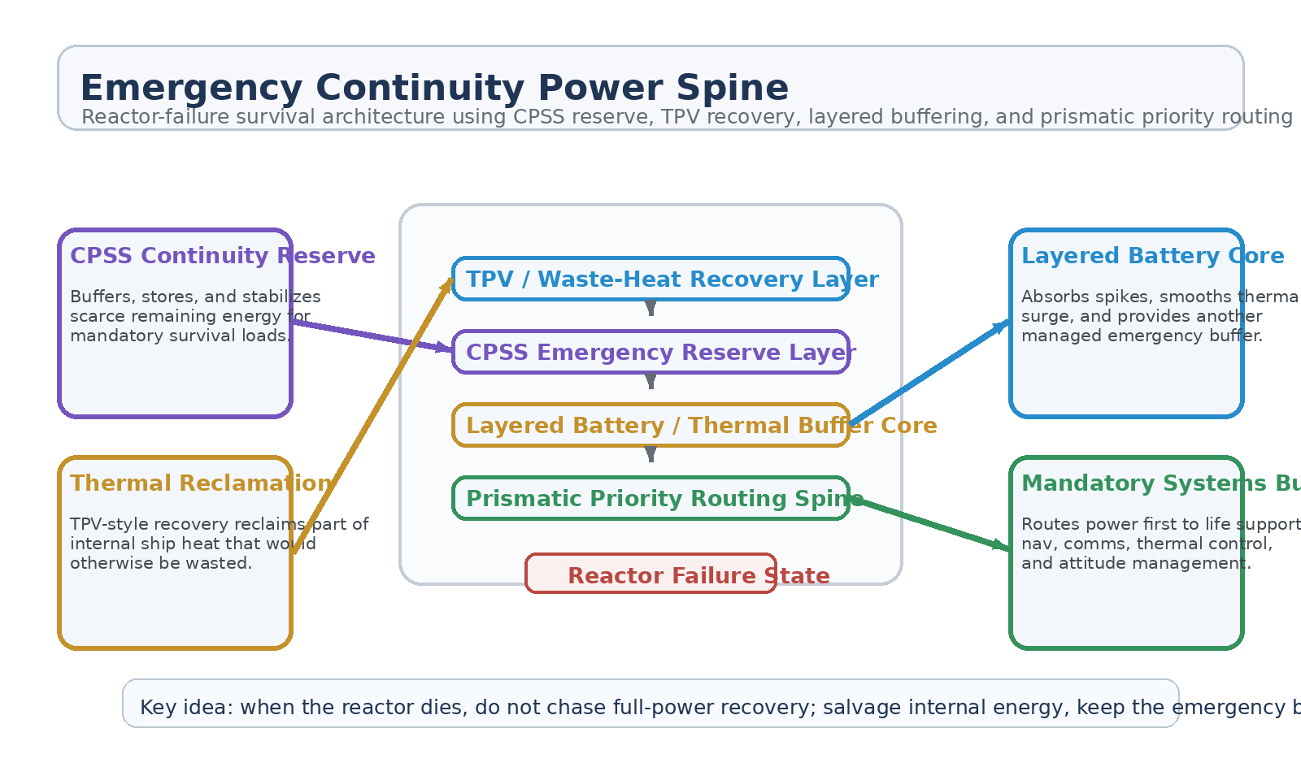
Figure 1. Emergency Continuity Power Spine with TPV heat recovery, CPSS reserve layer, layered battery buffering, and prismatic mandatory-systems routing.
1. Concept Thesis
The core idea is that a spacecraft should not treat total reactor loss as a purely binary event. Even after the main core fails, the ship still contains multiple forms of usable energy and multiple places to store or redirect it. Residual heat remains in hull structure, buses, electronics, plumbing, and propulsion hardware. Local reserve capacity remains in adaptive storage layers. Thermal gradients still exist. A continuity architecture can reclaim part of that energy and spend it on only the systems that protect survival.
This changes the doctrine from 'all power is gone' to 'full power is gone, but survival power can still be organized.'
2. Why the Combined Concepts Fit Together
The CPSS brief already defines an adaptive storage and distribution medium whose conductivity and release behavior can be field-managed in real time. That makes it a strong fit for an emergency reserve and smoothing layer.
The layered battery core concept already treats the inner structure as both thermal sink and energy transformer, explicitly allowing internal heat build-up to support secondary systems.
The tri-core propulsion paper defines CPSS-like tertiary layers as the subsystem responsible for buffering, waveform conditioning, and routing between major energy sources and downstream loads.
Prismatic Solar Skin extends the logic by showing that TPV and thermal-recovery layers can reclaim part of waste heat and feed it through a conditioned routing manifold to useful loads.
3. System Architecture
Layer | Subsystem | Primary Function | Emergency Role
L1 | TPV / Thermal Recovery Layer | Reclaim part of the ship's internal waste heat as usable electrical support. | Survival energy salvage
L2 | CPSS Emergency Reserve | Buffer, store, and stabilize reclaimed or remaining energy. | Continuity backbone
L3 | Layered Battery Core | Absorb spikes, smooth transient loads, and act as thermal-energy buffer. | Secondary reserve
L4 | Prismatic Routing Spine | Prioritize and distribute conditioned power to critical loads only. | Mandatory-systems manifold
L5 | Mandatory Systems Bus | Feed life support, nav, comms, thermal management, and attitude control. | Keep the ship alive

3.1 TPV as Internal Reclamation
The TPV role here is not to create energy from nowhere. Its value is in reclaiming part of the thermal burden already present inside the ship after failure. Hot structural sections, electronics bays, bus losses, and propulsion-adjacent systems all become candidates for partial recovery. This turns heat from a pure liability into a survival-energy source.
3.2 CPSS as the Emergency Utility Reserve
CPSS is the strongest continuity layer because it can act as both storage and regulation. Its adaptive conductivity logic makes it a plausible way to keep a damaged power environment from collapsing into noise. In emergency mode, CPSS should be thought of as the reserve that keeps scarce recovered power coherent enough to use.
3.3 Layered Battery Cores as Thermal Buffer Nodes
The layered battery concept adds a second survival mechanism: internal heat can be absorbed, delayed, transformed, and then partially reintroduced as controlled electrical support. This allows thermal shock and residual energy to be treated as managed reserve rather than immediate failure cascade.
3.4 Prismatic Priority Routing
The routing layer is where the ship decides what matters. Once the reactor is gone, the question is no longer how to power everything. The question is how to power the right things in the right order. A prismatic manifold is therefore best treated as the emergency priority bus that sends reclaimed and buffered power only where survival value is highest.
4. Mandatory Systems This Architecture Best Supports
• Life support and atmospheric circulation.
• Navigation, flight computers, and essential avionics.
• Communications and distress beacon continuity.
• Thermal management and coolant circulation.
• Attitude control and minimum safe maneuver authority.
• Selective emergency lighting and compartment control.
5. Why This Is Stronger Than a Simple Backup Battery
• It salvages internal heat instead of relying only on pre-stored charge.
• It combines reserve storage with thermal buffering and routing logic.
• It lets the ship degrade gracefully instead of failing as one giant electrical cliff.
• It supports local sector continuity even when the main reactor is dead.
• It treats emergency power as a living bus with priorities, not a dumb spare cell.
6. Operating Modes
Mode | Energy Behavior | Load Behavior | Outcome
Continuity Hold | TPV reclamation + CPSS reserve stabilize the emergency bus. | Only mandatory ship systems remain powered. | Immediate survival
Thermal Harvest | Layered cores absorb and convert residual internal heat. | Loads are shed aggressively to preserve endurance. | Longer operating window
Beacon First | Recovered energy is biased toward comms and nav. | Propulsion and comfort loads are minimized. | Improved rescue chance
Controlled Recovery | Reserve power is metered into attitude and minimum safe maneuvering. | Only low-authority motion is allowed. | Stabilized drift / return posture

7. Boundaries and Realism
Emergency Continuity Power Spine should be framed honestly. It is not a replacement for the main reactor. It is not a way to restore full ship performance after catastrophic failure. It is a survivability architecture that uses reserve storage, reclaimed heat, and strict priority routing to preserve only the functions that keep the platform alive. Its value lies in extending time, reducing chaos, and creating a controlled fallback state.
• Most credible as an emergency and degraded-mode power doctrine.
• Recovered heat extends survival but does not replace a full primary plant.
• Mandatory systems should be prioritized over comfort, peak thrust, or normal mission loads.
• Performance remains limited by thermal gradients, reserve capacity, and routing discipline.
8. Proof-of-Concept Build Path
Phase | Goal | Bench / Program Activity | Success Signal
P1 | Emergency reserve baseline | Validate CPSS-like buffering and stable low-power delivery into a mandatory-load surrogate bus. | Coherent emergency bus
P2 | Thermal recovery demo | Show that TPV-style recovery can reclaim part of heat otherwise lost in a controlled testbed. | Measured salvage output
P3 | Layered-core buffering | Integrate a layered battery / thermal sink node and evaluate transient smoothing. | Reduced thermal shock
P4 | Priority routing | Route scarce recovered energy to a ranked set of loads under fault conditions. | Correct load shedding behavior
P5 | Reactor-failure scenario | Compare no-continuity and continuity-spine behavior during a simulated core-loss event. | Longer survivable operations

9. Conclusion
Emergency Continuity Power Spine reframes reactor failure as a survivability-management problem rather than a simple dead-state event. TPV layers reclaim heat already inside the ship. CPSS keeps the emergency bus stable. Layered battery cores absorb and transform residual thermal stress. Prismatic routing makes sure the right systems stay alive first.
As a white paper PoC, the concept is strongest when treated as a graceful-failure architecture: not a miracle resurrection of full power, but a disciplined way to buy the ship more life after the heart stops.
Working one-line doctrine: When the reactor fails, salvage internal energy, keep the emergency bus coherent, and feed only the systems that keep the ship alive.

